Loop Statements

In programming, sometimes we need to execute the block of code repeatedly while some condition evaluates to true. However, loop statements are used to execute the set of instructions in a repeated order. The execution of the set of instructions depends upon a particular condition.

In Java, we have three types of loops that execute similarly. However, there are differences in their syntax and condition checking time.

1. for loop
2. while loop
3. do-while loop

Let's understand the loop statements one by one.

Java for loop

In Java, [for loop](https://www.javatpoint.com/java-for-loop) is similar to [C](https://www.javatpoint.com/c-programming-language-tutorial) and [C++](https://www.javatpoint.com/cpp-tutorial). It enables us to initialize the loop variable, check the condition, and increment/decrement in a single line of code. We use the for loop only when we exactly know the number of times, we want to execute the block of code.

1. **for**(initialization, condition, increment/decrement) {
2. //block of statements
3. }

The flow chart for the for-loop is given below.

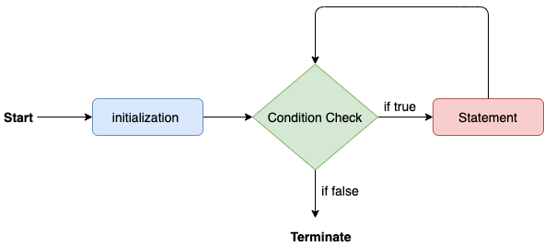

The Java *for loop* is used to iterate a part of the program several times. If the number of iteration is **fixed**, it is recommended to use for loop.

There are three types of for loops in Java.

* Simple for Loop
* [For-each](https://www.javatpoint.com/for-each-loop) or Enhanced for Loop
* Labeled for Loop

## **ava Simple for Loop**

A simple for loop is the same as [C](https://www.javatpoint.com/c-programming-language-tutorial)/[C++](https://www.javatpoint.com/cpp-tutorial). We can initialize the [variable](https://www.javatpoint.com/java-variables), check condition and increment/decrement value. It consists of four parts:

1. **Initialization**: It is the initial condition which is executed once when the loop starts. Here, we can initialize the variable, or we can use an already initialized variable. It is an optional condition.
2. **Condition**: It is the second condition which is executed each time to test the condition of the loop. It continues execution until the condition is false. It must return boolean value either true or false. It is an optional condition.
3. **Increment/Decrement**: It increments or decrements the variable value. It is an optional condition.
4. **Statement**: The statement of the loop is executed each time until the second condition is false.

**Syntax:**$150 Million for Using Phone Numbers and Emails To Target Ads

1. **for**(initialization; condition; increment/decrement){
2. //statement or code to be executed
3. }

## **Java Nested for Loop**

If we have a for loop inside the another loop, it is known as nested for loop. The inner loop executes completely whenever outer loop executes.

## **Java for-each Loop**

The for-each loop is used to traverse array or collection in Java. It is easier to use than simple for loop because we don't need to increment value and use subscript notation.

It works on the basis of elements and not the index. It returns element one by one in the defined variable.

**Syntax:**

1. **for**(data_type variable : array_name){
2. //code to be executed
3. }

Consider the following example to understand the proper functioning of the for loop in java.

**Calculation.java**

1. **public** **class** Calculattion {
2. **public** **static** **void** main(String[] args) {
3. // TODO Auto-generated method stub
4. **int** sum = 0;
5. **for**(**int** j = 1; j<=10; j++) {
6. sum = sum + j;
7. }
8. System.out.println("The sum of first 10 natural numbers is " + sum);
9. }
10. }

**Output:**

The sum of first 10 natural numbers is 55

Java for-each loop

Java provides an enhanced for loop to traverse the data structures like array or collection. In the for-each loop, we don't need to update the loop variable. The syntax to use the for-each loop in java is given below.

1. **for**(data_type var : array_name/collection_name){
2. //statements
3. }

Consider the following example to understand the functioning of the for-each loop in Java.

**Calculation.java**

1. **public** **class** Calculation {
2. **public** **static** **void** main(String[] args) {
3. // TODO Auto-generated method stub
4. String[] names = {"Java","C","C++","Python","JavaScript"};
5. System.out.println("Printing the content of the array names:\n");
6. **for**(String name:names) {
7. System.out.println(name);
8. }
9. }
10. }

**Output:**

Printing the content of the array names:

Java

C

C++

Python

JavaScript

Java while loop

The [while loop](https://www.javatpoint.com/java-while-loop) is also used to iterate over the number of statements multiple times. However, if we don't know the number of iterations in advance, it is recommended to use a while loop. Unlike for loop, the initialization and increment/decrement doesn't take place inside the loop statement in while loop.

It is also known as the entry-controlled loop since the condition is checked at the start of the loop. If the condition is true, then the loop body will be executed; otherwise, the statements after the loop will be executed.

The syntax of the while loop is given below.

1. **while**(condition){
2. //looping statements
3. }

The flow chart for the while loop is given in the following image.

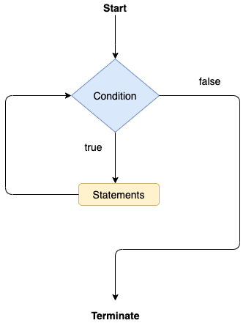

1. Condition: It is an expression which is tested. If the condition is true, the loop body is executed and control goes to update expression. When the condition becomes false, we exit the while loop.

**Example**:

i <=100

2. Update expression: Every time the loop body is executed, this expression increments or decrements loop variable.

Consider the following example.

**Calculation .java**

1. **public** **class** Calculation {
2. **public** **static** **void** main(String[] args) {
3. // TODO Auto-generated method stub
4. **int** i = 0;
5. System.out.println("Printing the list of first 10 even numbers \n");
6. **while**(i<=10) {
7. System.out.println(i);
8. i = i + 2;
9. }
10. }
11. }

**Output:**

Printing the list of first 10 even numbers

0

2

4

6

8

10

Java do-while loop

The [do-while loop](https://www.javatpoint.com/java-do-while-loop) checks the condition at the end of the loop after executing the loop statements. When the number of iteration is not known and we have to execute the loop at least once, we can use do-while loop.

It is also known as the exit-controlled loop since the condition is not checked in advance. The syntax of the do-while loop is given below.

1. **do**
2. {
3. //statements
4. } **while** (condition);

The flow chart of the do-while loop is given in the following image.

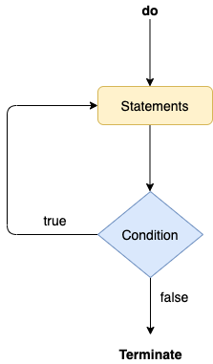

Consider the following example to understand the functioning of the do-while loop in Java.

**Calculation.java**

1. **public** **class** Calculation {
2. **public** **static** **void** main(String[] args) {
3. // TODO Auto-generated method stub
4. **int** i = 0;
5. System.out.println("Printing the list of first 10 even numbers \n");
6. **do** {
7. System.out.println(i);
8. i = i + 2;
9. }**while**(i<=10);
10. }
11. }

**Output:**

Printing the list of first 10 even numbers

0

2

4

6

8

10

Jump Statements

Jump statements are used to transfer the control of the program to the specific statements. In other words, jump statements transfer the execution control to the other part of the program. There are two types of jump statements in Java, i.e., break and continue.

Java break statement

As the name suggests, the [break statement](https://www.javatpoint.com/java-break) is used to break the current flow of the program and transfer the control to the next statement outside a loop or switch statement. However, it breaks only the inner loop in the case of the nested loop.

The break statement cannot be used independently in the Java program, i.e., it can only be written inside the loop or switch statement.

**The break statement example with for loop**

Consider the following example in which we have used the break statement with the for loop.

**BreakExample.java**

1. **public** **class** BreakExample {
3. **public** **static** **void** main(String[] args) {
4. // TODO Auto-generated method stub
5. **for**(**int** i = 0; i<= 10; i++) {
6. System.out.println(i);
7. **if**(i==6) {
8. **break**;
9. }
10. }
11. }
12. }

**Output:**

0

1

2

3

4

5

6

**break statement example with labeled for loop**

**Calculation.java**

1. **public** **class** Calculation {
3. **public** **static** **void** main(String[] args) {
4. // TODO Auto-generated method stub
5. a:
6. **for**(**int** i = 0; i<= 10; i++) {
7. b:
8. **for**(**int** j = 0; j<=15;j++) {
9. c:
10. **for** (**int** k = 0; k<=20; k++) {
11. System.out.println(k);
12. **if**(k==5) {
13. **break** a;
14. }
15. }
16. }
18. }
19. }

22. }

**Output:**

0

1

2

3

4

5

Java continue statement

Unlike break statement, the [continue statement](https://www.javatpoint.com/java-continue) doesn't break the loop, whereas, it skips the specific part of the loop and jumps to the next iteration of the loop immediately.

Consider the following example to understand the functioning of the continue statement in Java.

1. **public** **class** ContinueExample {
3. **public** **static** **void** main(String[] args) {
4. // TODO Auto-generated method stub
6. **for**(**int** i = 0; i<= 2; i++) {
8. **for** (**int** j = i; j<=5; j++) {
10. **if**(j == 4) {
11. **continue**;
12. }
13. System.out.println(j);
14. }
15. }
16. }
18. }

**Output:**

0

1

2

3

5

1

2

3

5

2

3

5